Accident Analysis using GIS tools

Vishwaradhya

1nt21ec173.vishwaradhya@nmit.ac.in

Shraddha Muragi

1nt21ec138.shraddha@nmit.ac.in

Vidhi Mathur

1nt21ec170.vidhi@nmit.ac.in

Institution Mentor

Dr. Rajesh N

Industry Mentor

Abhishek Nandy

## Project analysis

Road traffic is considered as one of the negative factors that hinder the economic development of developing countries due to the great losses that cause economic and social concerns. Traffic safety is an important factor in the development of sustainable transport and plays an important role. Today, the main effects of modern road transport are the damage, injury and death that occur in accidents. The success of traffic safety and road development depends on accurate and reliable traffic accident data analysis. This study examines the incidence of traffic accidents on 3 highways, NH 47 Gandhipuram to Avinashi, NH-209 Gandhipuram to Annur, and NH 67 Gandipuram to Mettupalayam in the Coimbatore area. It also discussed the application of ArcGIS software to identify high-risk areas and highway safety areas. As a result of the treatment of these unexpected areas (black spots), the incidence of accidents will decrease.

## Introduction

Methodologies for predicting accidents have been widely adopted studied in the past. Prediction models are mostly causative types where the number of accidents is taken as a function number of independent variables. They were there recently a study to identify accident prone locations using fuzzy a neural network classifier approaches. However, such methods are highly dependent on traffic flow data such as the average day. Traffic and data collected by the traffic police from accident sites. However, traffic flow data is rarely available sufficient quantity or precision to justify these regressions approaches. In addition, the traffic police may not be able to collect all the necessary data needed to perform the analysis using that data. Considering all the factors mentioned above, it is necessary to develop a model that can help in forecasting. Risk zone on the given road network. This article describes a model developed to identify black spots on roads using a kernel and Overlay analysis in GIS. GIS is location-based information analyze spatial and non-spatial data. Therefore, the model for identifying the scene of an accident on the roads can be easy integrated using GIS.

#### Study Area:

Coimbatore is the second upcoming smart city in India and is called the Manchester of South India. Longitude Coimbatore lies between 76.65 decimal degrees to 77.29 decimal places degrees. Latitude lies between 10.22 decimal degrees-11.41 decimal degrees. The total area of ​​Coimbatore is 471 square kilometres (Figure 1). Coimbatore Corporation has eight blocks, One Corporation, 228 Village Panchayats, 44 Town Panchayats and 6 Municipality. The percentage of population in Coimbatore is 89.23. Population density is higher in urban and semi-urban areas urban areas compared to rural areas i.e. villages Panchayats. There are four national highways that connect three states (Tamil Nadu, Kerala, Karnataka). NH roads are designed for people to walk through the city resulting in a heavy traffic jam.

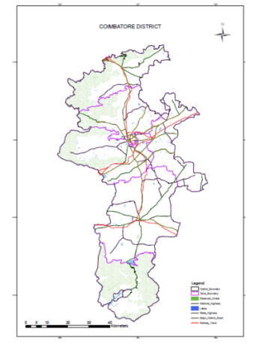

Fig. 1. Study area

## Methodology

The step-by-step procedure is explained below:

### Data Collection

To identify accident-prone zones and traffic jams, data is collected from relevant departments. Data is divided into two, i.e. spatial and non-spatial data.

# Spatial Data

Spatial data provides accurate geometric information such as location, boundary extent and road network. The map (OSM) was obtained from the Survey of India, Updated taluk the map was obtained from the Survey and Settlement Department and the road network map was obtained from the Ministry of Roads.

# Non-Spatial data

Information available on spatial data is called non-spatial data. Details of the accident include the date of the accident, Time, type of accidents, vehicles involved, gender, license or Non-Licensed, Drunk and drive etc. These details were collected from Police Commissionerate Coimbatore. The Bus stop details such as route and bus number were obtained by Coimbatore transport Corporation. HOSPITAL Information was collected from Coimbatore Health Department.

### Data processing

Ground Control Points (GCPs) were collected with the help of handheld GPS in WGS1984 datum. The scene of the accident locations are converted to shapefiles using ArcGIS software. Accident data has been added as attribute data. OS maps were georeferenced using the given location. All OSM maps, they were mosaic into a single map. Updated taluk and road the network map was georeferenced using georeferenced OSM to identify the current taluk and road network. Digitized method is used to extract vector data from the underlying raster data. The extracted layers are district boundaries, taluk boundaries, National Highway, National Highway, Main District Highway, Railway line, reserved forest and lakes. These layers were saved as shapefiles. These extracted and generated layers are added to the geographic database.

## Analysis and results

###### Buffer Analysis

Buffer analysis was used to create the buffer polygon to find the scene of the accident and its surroundings. Location of bus stops were limited to a radius of 500 m with reference to the accident site. When the accident location overlaps the buffer radius, bus stops were removed to minimize the accident overload.

#### Accident Spot

Accident locations are visualized by an accident overlay place by the state highway. Figure 2 shows different types of accidents (safe, injury and death) with respective years.

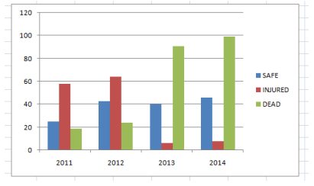 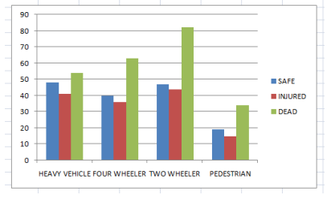

Fig. 2. Graph showing the variation of type of accident Fig. 3. Graph showing the variation of type of vehicle

#### Accident hotspots

Accident hotspots are divided into three categories based on a rank-based analysis system. Base rank depends on different samples. Figure 3 shows the vehicle variants connected to the hot spot area. Figure 4 shows the type of vehicles involved in the event with respect to years.

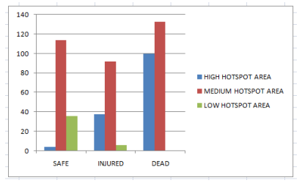

Fig. 4. Graph showing type of accident in hotspot area

###### Kernel density Analysis

Kernel density analysis is used to find the probability of an accident zone using information about the active scene of the accident. Probability zones are divided into high, medium and low. Will appear danger zone in red (Figures 5 and 6).

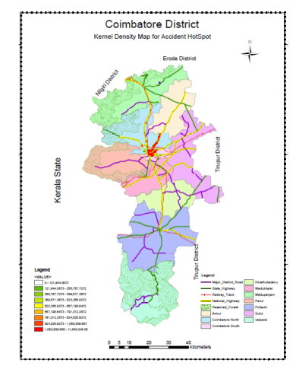Fig. 5. Kernel density analysis

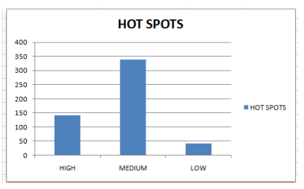

Fig. 6. Graph variation of kernel density analysis

#### Health Information

GIS analysis will also display multispecialty hospital near the accident site. This information can be used to find the distance between the accident site and multispecialty hospital. Travel time can also be determined.

#### Police Jurisdiction

An analysis was also carried out to determine the accident sites which they fall under the jurisdiction of a specific police station.

###### Overlap analysis:

Overlap analysis is a group of methods used in optimal site selection or suitability modeling. It's a technique for the application of a common scale of values ​​to diverse and various inputs to create an integrated analysis.

#### Weighted sum

A weighted sum overlap analysis follows the same general steps overlay analyzes described above. Using the Sum tool, supplemented by other Spatial Analyst tools, an additive overlay analysis can be implemented. Values ​​for input layers must be reclassified before use weighted sum tool. Unlike the weights in the weighted Overlay tool, weights assigned to input rasters can be any value and need not be added to a specific amount. When addition of input rasters, output values ​​of the weighted sum tool are the direct result of addition multiplying each value using scales. Unlike the weighted overlay, the values ​​are is not changed back to the defined scale; therefore it preserves attribute resolution of the values ​​specified in the model. The weighted sum assumes that more favorable factors result higher values ​​in the resulting output raster, thus identifying these places are the best(Figure 7).

#### Web Information System

The following information is placed on the website for the future update and appear user-friendly to public users. The link is [www.aiscbe.in](http://www.aiscbe.in)

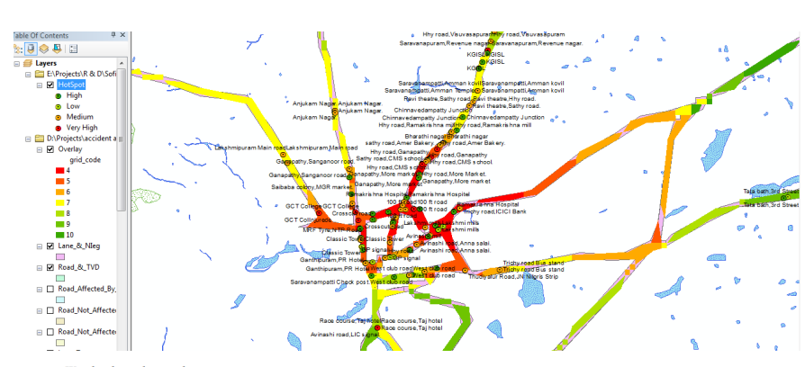

Fig.7. Weighted overlay analysis

## Conclusion

The study was an attempt to find out the most vulnerable accident sites or black spots in Coimbatore districts using GIS. Method of weighted overlay analysis was used to assess accident sites. Based on the analysis Periyanayakampalayam, Sarcarsamakulam, Thondamuthur, Madukkari and sulur were identified as the most vulnerable places of accidents and proposed a possible alternative or corrective measure to improve the transport system these places from which the decision maker we can choose appropriate measure for the location. The method was found to be provided sufficient effectiveness in identifying black spots secondary data are available.

## References

1. Yalcin G, Duzgun HS. Spatial analysis of two-wheelers Traffic accidents: Osmaniye in Turkey. KSCE J Civil Eng 2015; 7: 2225-2232.

2. Cairda KJ, Johnstonb AK, Chelsea R, Willness+ C, Asbridge DM, Steele P. A meta-analysis of the effects of text messaging on management. Accident Anal Prevent 71: 311-318.

3. Jonasson KJ, Rootzén H. Internal verification of near misses in naturalistic studies of driving: Próběžná a multidimensional approach. Accident Anal Prevent 62: 102-109.

4. Sorate RR, Kulkarni RP, Bobade SU, Patil MS, Talathi AM, Sayyad IY, Apte SV. Accident identification Black Places on National Highway 4 (New Katraj Tunnel to Chandani Chowk). IOSR J Mech Civil Eng 2015; 12:61-67.

5. Dholia P, Shinkar P. Identification of the accident prone. The case study of Rajkot city is spread over an urban area. Int J Sci Res Develop 2016; 4: 1722-1725.

6. Kumar DM, Arun J, Pradeep R. Vehicle speed monitoring. System for safe driving and minimization of accidents on the stomach Flat. Int J Res Electric Eng 2016; 3: 2349-2503